LAB EXERCISE 20 - GEOLOGIC MAPPING

Name: | Course ID:
Geologic maps are a geologist’s best friend. They depict the exposed surface geology. Formations and similar units are color coded to aid in identification and interpretation. The map below is an incomplete geologic map of the Shivwits area in far Southwestern Utah. A legend for the different rock formations and their geologic ages is also given.
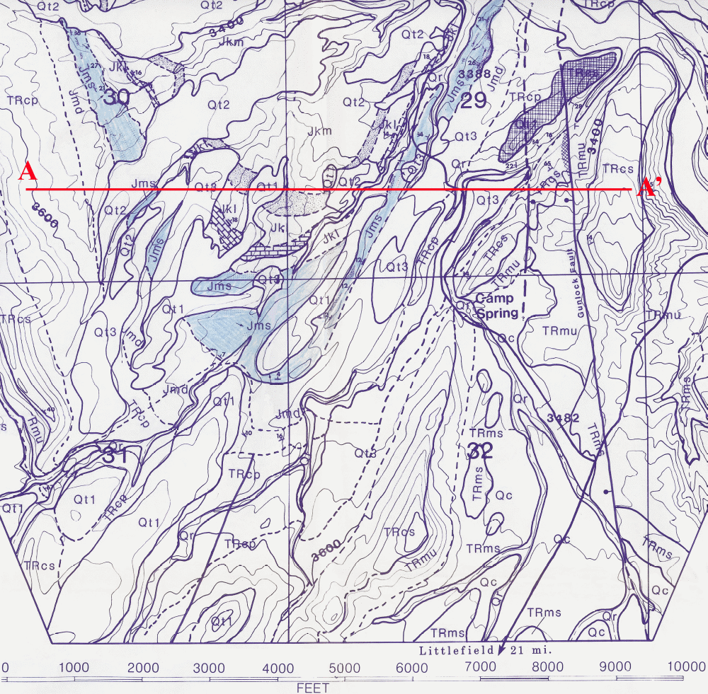
The early Jurassic Springdale Sandstone Member of the Moenave (Jms) formation is shaded blue. Complete the geologic map by color shading all formations / members present with some differing colors of your choice. (Hint: Mesozoic aged rocks are often colored in variations of blue or green shades). Use the same color scheme for the map explanation and in your cross sectional profile. Quaternary terrace deposits are often unconsolidated and horizontal, covering the underlying ancient lithologies. After completion of map, explanation legend and cross section, answer the questions listed below:


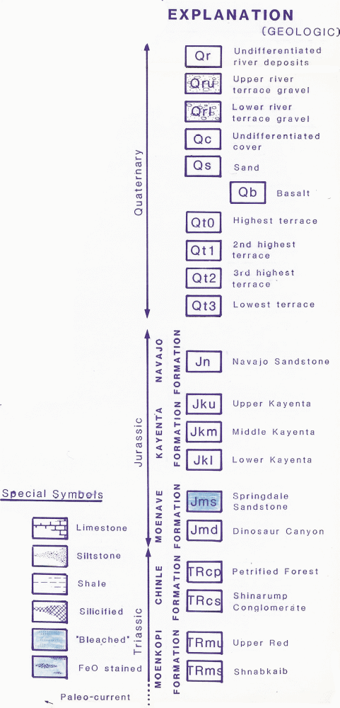
Guided by the stratigraphy given in the ”Explanation,” mark all possible unconformities with thick red lines on the map.

Complete the cross sectional profile A - A’ as indicated on the geologic map. The contour interval is 40ft. Transfer not only elevation points but mark and transfer formation boundaries as well. Pay attention to strike and dip symbols and show extent of formations in the sub surface as much as possible.

From the map topography and the unit names, identify the possible lithologies and record them on the “Explanation” next to the appropriate unit.

What geologic structure is present on the map?

Briefly state the suggested geologic history of the area. (In 5 sentences or less.)

